Activity No: 4.2
Activity Title: Hands-on Activity 4.2: Characters and Strings
Course Code: CPE 007 | Program: Computer Engineering
Course Title: Programming Logic and Design | Date Performed: 09-15-26
Section: CPE11S4 | Date Submitted: 09-15-26
Name(s): Lozano, Molier Vincent D. | Instructor: Sir Robin Valenzuela
Objectives
Instructions
Output/Answer
Code:
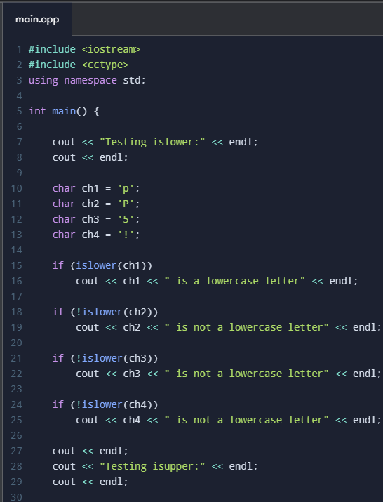
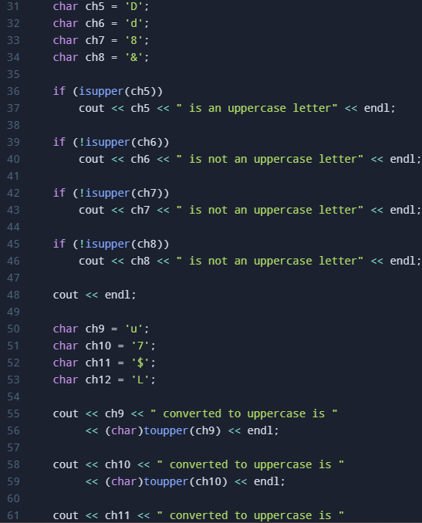
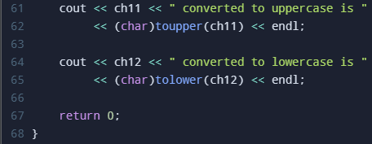

Output:
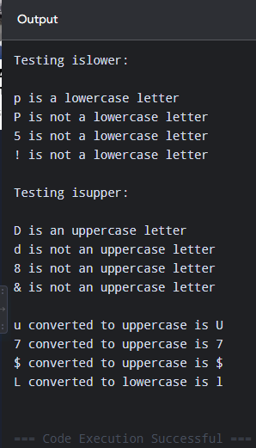
Supplementary Activity (if any)
1.
Code:
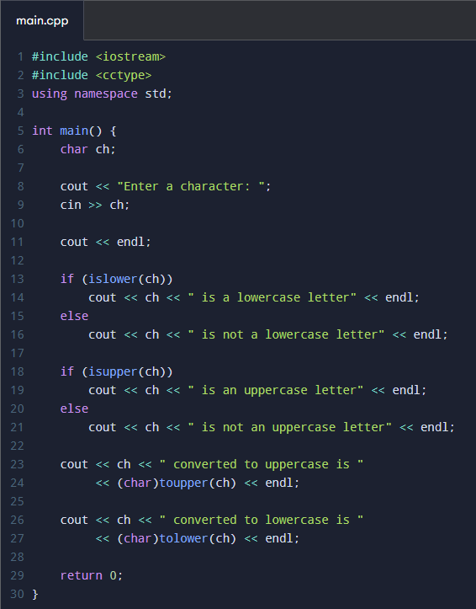

Output:
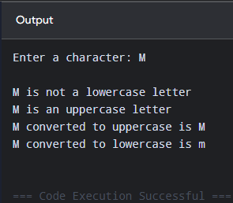

2.
Code:
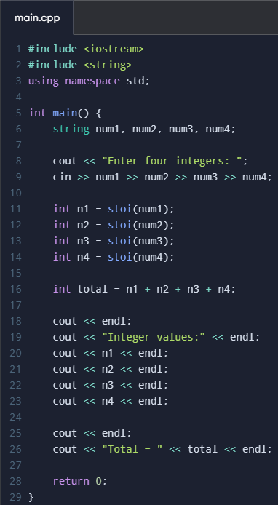

Output:
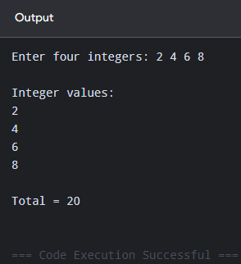

3.
Code:
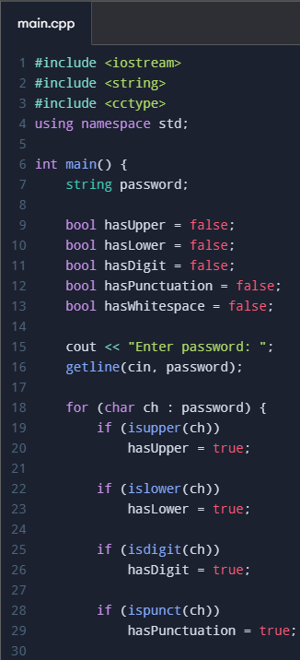
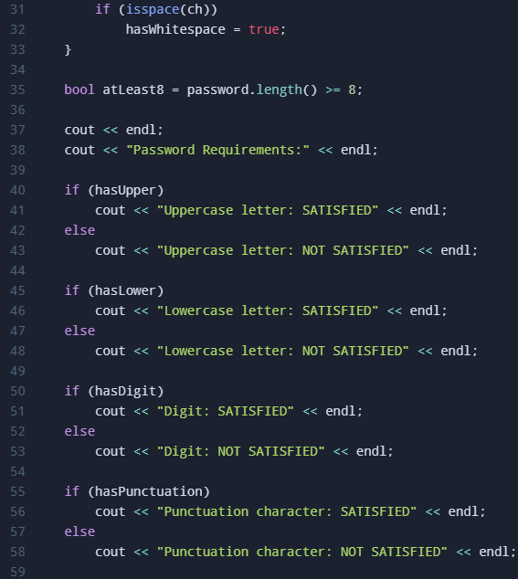
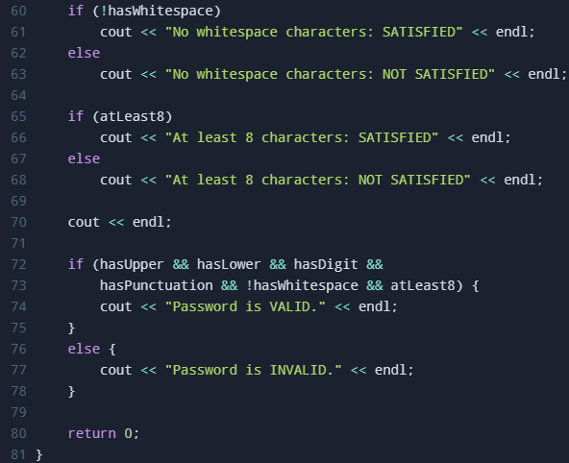

Output:
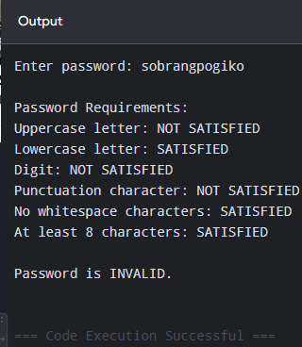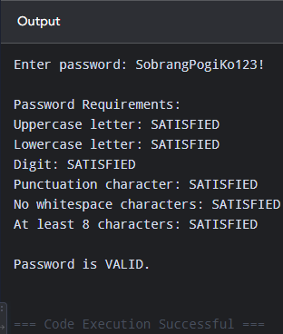
Conclusion
Assessment Rubric: SO 7

